**PHASE - 1**

**Problem Definition and design thinking**

|  |  |
| --- | --- |
| **Date** | **28 AUG 2023** |
| **Team ID** | **Group 4** |
| **Project name** | **Fake news detection using NLP** |
| **Maximum mark** |  |

***Abstract:***

In this project, we aim to develop a robust fake news detection system using Natural Language Processing (NLP) techniques. By analyzing the language patterns, linguistic features, and credibility of news sources, our will be able to identify and flag potentially misleading or fabricated news articles. Through the application of advanced NLP algorithms, such as sentiment analysis, source analysis, and linguistic analysis, we aim to provide users with a reliable and accurate means of distinguishing between trustworthy and fake news sources. The system will be designed to continuously learn and adapt to evolving fake news tactics, ensuring its effectiveness and relevance in combating the spread of misinformation. We’ll use NLP techniques to develop a system that can detect fake news. By analyzing language patterns, credibility of news sources, and using advanced NLP algorithms, Our System aim to accurately identify and flag misleading or fabricated news articles. This will help users distinguish between trustworthy and fake news sources, contributing to a more informed and reliable information ecosystem.

***Keywords:***fake news, detection, NLP techniques, language patterns, sentiment analysis, source analysis, combating misinformation.

***Problem Definition:***

The problem is the spread of fake news, which can mislead and deceive people. We want to develop a solution using NLP to detect and filter out fake news, ensuring that users have access to reliable and accurate information.

***Design thinking Approach****:*

**Empathize:** Understand the impact of fake news on individuals and society. Gather insights from users, journalists, and fact-checkers to identify their pain points and needs.

Define: Clearly define the goals and objectives of the solution. Determine the key metrics for evaluating the effectiveness of fake news detection, such as accuracy, speed, and scalability.

Ideate: Brainstorm potential NLP techniques and algorithm for fake news detection. Consider sentiment analysis, fact-checking, source analysis, linguistic analysis, and other approaches discussed earlier.

Implement: Deploy the fake news detection system as a web application or integrate into existing news platforms. Ensure scalability, efficiency and user-friendly interfaces for seamless integration.

Monitor: Continuously monitor the system performance, accuracy, and user satisfaction. Regularly update the system to address emerging fake news trends and improve detection capabilities.

***Empathy map Canvas:***

This is focuses on understanding the thoughts and emotions of users who consume news. It helps us empathize with their concerns about misinformation and the impact it can have on their beliefs and decision. Explores the actions and behaviors of users when they encounter fake news. It helps us understand how they react, whether they share or report the news, and how they verify the authenticity of the information.

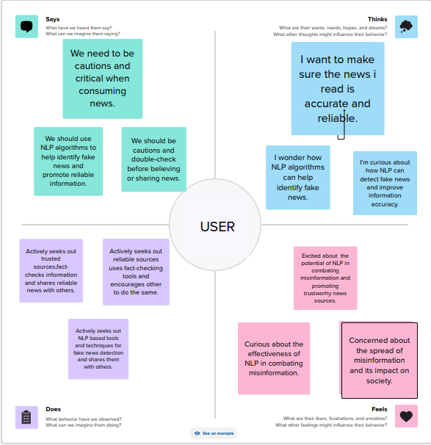

***Brainstorming:***

Natural Language processing models can be trained to analyze the linguistic pattern and semantic structures in news articles to identify potential indicators of fake news.

Developing algorithms that can detect inconsistencies or contradictions within news articles, such as conflicting information or biased language, which may indicate the presence of fake news.

Building systems that can verify the authenticity of news by cross-referencing information with reliable sources, fact-checking organizations, or official databases.

